MongoDB Compass

Adapted from [MongoDB Compass - javatpoint](https://www.javatpoint.com/mongodb-compass)

# Introduction

MongoDB Compass is a GUI for MongoDB. It is also known as MongoDB GUI. MongoDB allows users to analyze the content of their stored data without any prior knowledge of MongoDB query syntax. When we explore exploring our data in the visual environment, we can use Compass GUI to optimize performance, manage indexes, and implement document-validation.

All the versions of MongoDB Compass are opensource (i.e., we can freely deploy and view the repositories of all MongoDB GUI versions). The source repositories of MongoDB compass can be found on the following link of GitHub

# Step 0: Download and Install MongoDB Compass

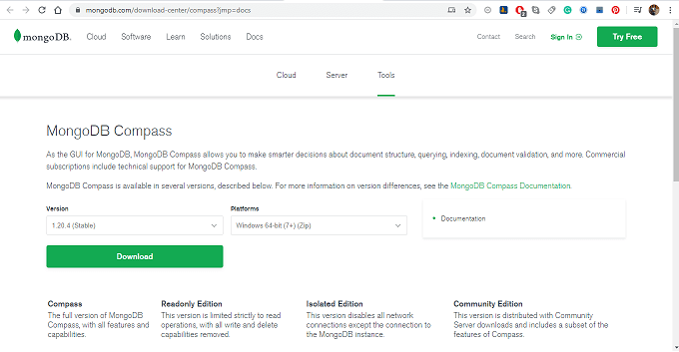

# Step 1: Establishing connection with MongoDB Compass

When you log in to Compass, an initial dialogue will appear

To get the deployment connection string for an Atlas cluster, go to your Atlas cluster view.

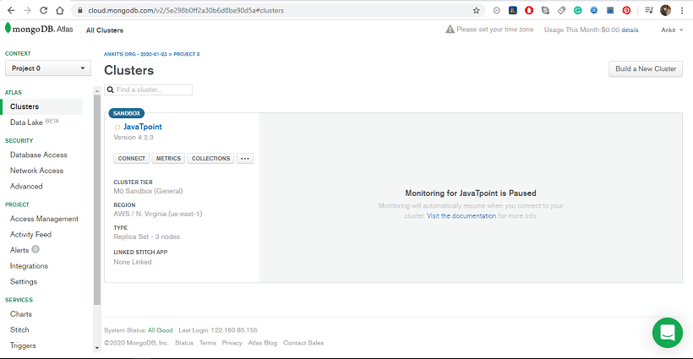

Click Connect with MongoDB Compass and copy the provided connection string

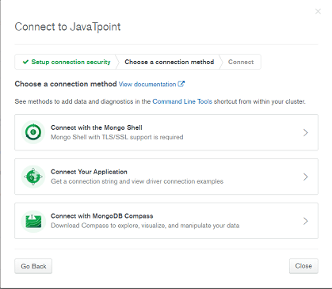

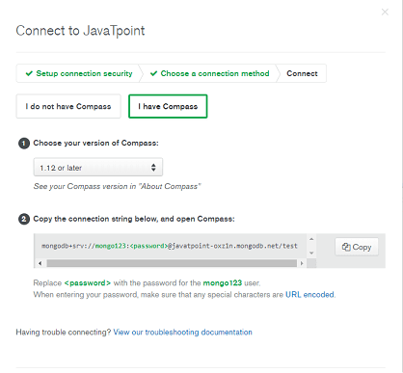

Click on connect button, to connect and navigate to the Compass GUI Home Page

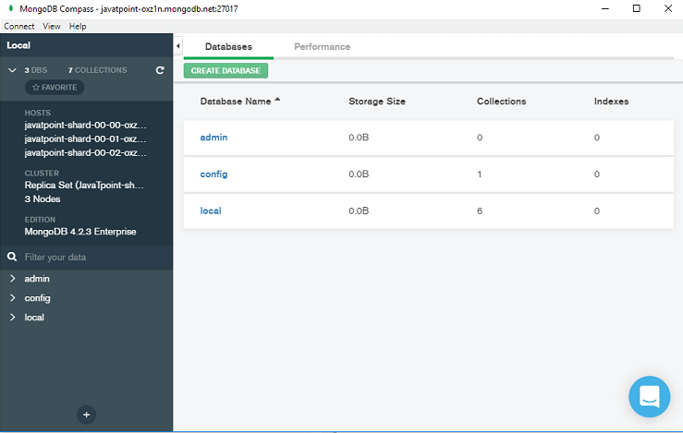

# Creating and Managing Database using Compass

When you are connected to the MongoDB Atlas or Mongo Shell, the following window will appear. Inside this window, you can see the Database tab. The Database window shows the lists of all the existing databases for your MongoDB deployment.



# Create a Database in Compass

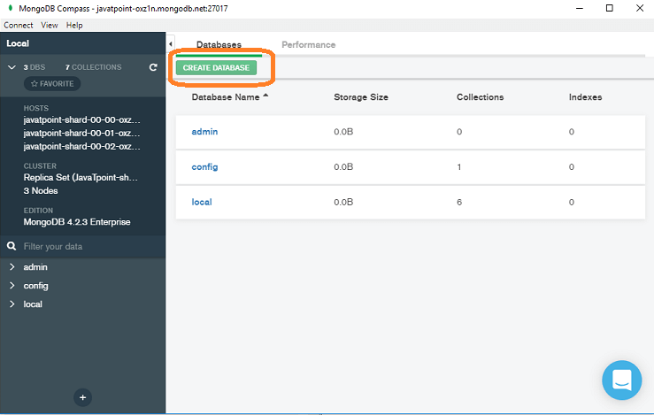

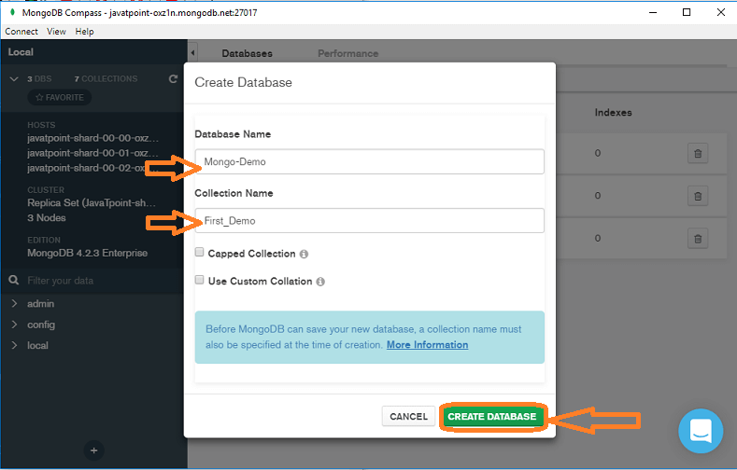

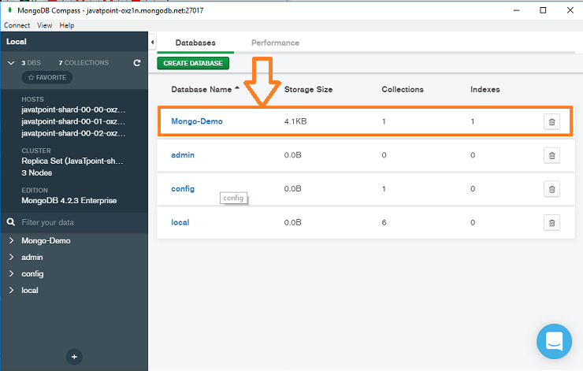

# Drop a Database in Compass

Click on the trash icon that will appear when you hover over the Database name, after that a confirmation dialog appears

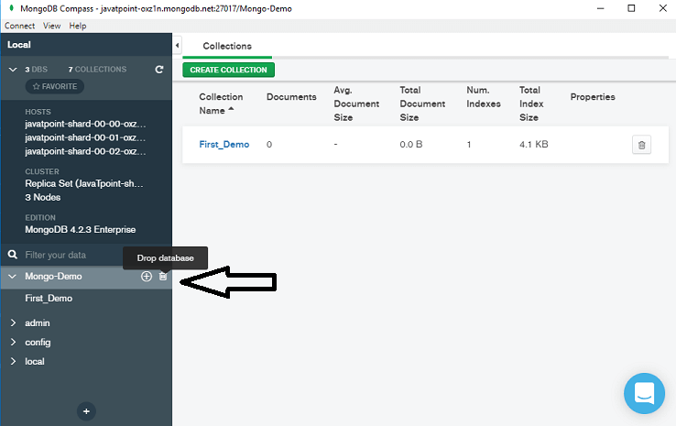

In the pop-up window, enter the name of the Database that you want to delete

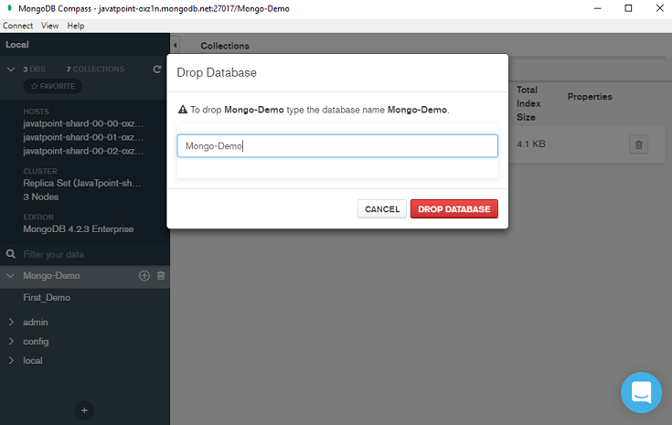

# Create a Collection in MongoDB Compass

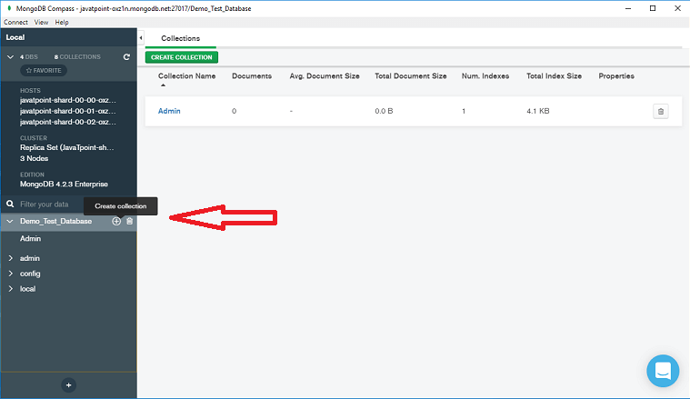

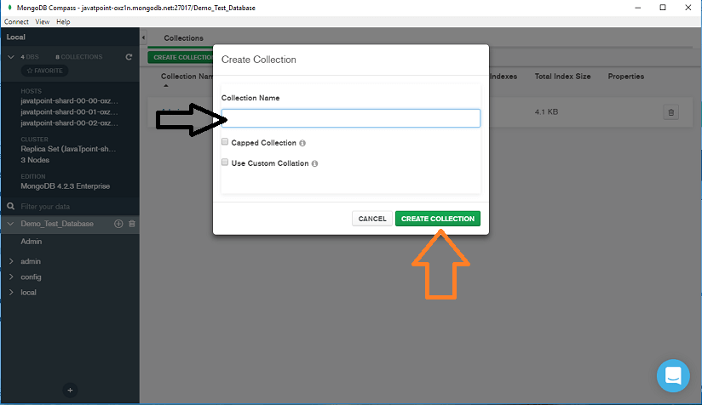

# Managing Documents in MongoDB Compass

